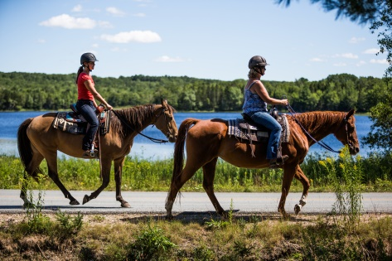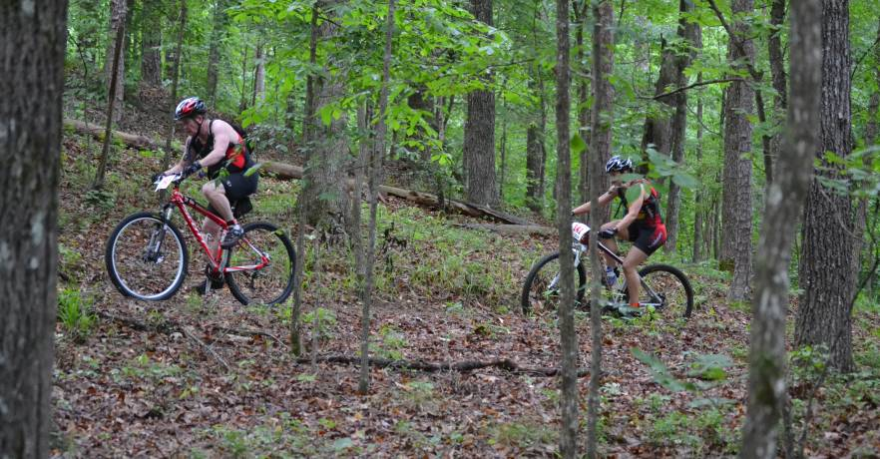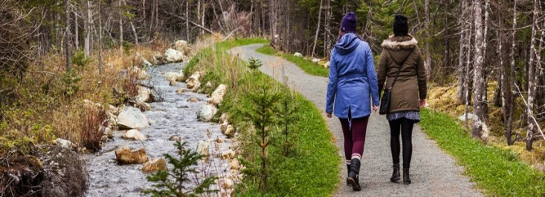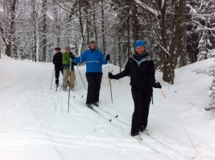
Recreation Trails in New Ross!
The Strategic Plan Action Committee of the New Ross Regional Development Society began working on the concept of developing a “Trail Plan” for New Ross 3 years ago. Since this time, much work has been done to build a plan to create a “spectrum of trail opportunities in New Ross to appeal to a wide number of user types”. This past year we have formalized as a group and are now officially “The New Ross Trails Society”. We have held some wonderful events and have continued engagement with the community to learn more of what New Ross residents would like to see from trails in New Ross and explore trail opportunities. Such events included a family Bike Ride at Ross Farm, a guided hike to Popnar Hill, a community survey about trails and extra curricular activity in New Ross, visits to other local recreation trails, meetings with land owners for their valued input on what trials look like and could mean in our area, and many “kitchen table” conversations about the needs and wants of our community.
Currently the accessibility to trails in New Ross may be limited and we’re hoping to expand on this.
A few very exciting opportunities have arose from these meetings, events and gatherings, and one in particular that we are currently working on now! With the expressed consent and engagement of the Murphy family, we are aiming to develop trails on their property on Porcupine Hill. In 2017, they lost eight-month-old Ruby. New Ross responded with an incredible show of support and compassion. In recognition of this, The Murphy Family would like to say ‘thank you’ and have chosen to open their tree lot to the public for the enjoyment of all. They will maintain the lot as a working Christmas Tree farm, but they are excited to expand the potential of the property to include recreational trails. They understand that people have many different interests and that the property will attract many different types of users. Through sound development and management, we all feel that several excellent trail experiences can be created. Integral to this plan is the recognition of Ruby. There is one location in particular on Porcupine Hill that has an expansive view of the Village below and the rolling hills beyond. From this location one can see Popner Hill, Lake Lawson, the Gold River Valley, and the school in one sweeping view. This location will be Phase 1 of our trail project and will serve as an anchor point for the trail plan that develops. We mark this spot now as a place of peace and quiet contemplation; and dedication to all the wonderful children of New Ross. NRTS is thankful for the generous opportunity the Murphy family have afforded us and the entire community of New Ross. We hope that this will be the first of many trails that can be connected into a regional network. We have prepared a TENDER to see if someone locally would like to work on phase 1 of this project.
If YOU have some ideas for a Trail Plan, we’d love to hear about them or to learn more please contact: (902) 689-2004, or sobroome@hotmail.com. ~Happy Trails~

Trail Construction
TENDER

This TENDER is open to applicants interested in the trail construction for Phase 1 of the aforementioned trail project, led by the New Ross Trails Society in conjunction with the Murphy family. Please pick up a copy of the TENDER document at the, New Ross Family Resource Centre. All questions will be addressed at the mandatory site visit. To set up an appointment date/time for this site visit please contact, Sheena Isenor: (902) 277-1450, or email: sobroome@hotmail.com.

